**Project 1**

Special Instructions to run the java files in Project 1:

* First we need to compile all the .java files in order for them to run successfully. To do so run the below commands at the location where all the source files are present:
  + javac CASCII.java
  + javac Message_Encoding.java
  + javac SDES_Encoding.java
  + javac SDES.java
  + javac TripleSDES.java
* For **Part 1** of the project where we find the ciphertext or plaintext of the given problems using **SDES algorithm**, please run the file named as SDES.java
  + To run the file run the command: **java SDES.java**
  + After the above file is run successfully we will see the below output:

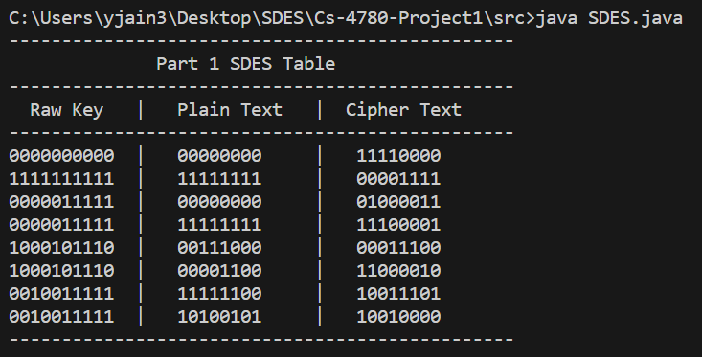

The above screenshot has the answers to the problems given in Part 1 where in we need to find the Cipher text or the Plain text of the problem using SDES algorithm.

* For **Part 2** of the project where we find the ciphertext or plaintext of the given problems using **TripleSDES algorithm**, please run the file with named as TripleSDES.java
  + To run the file, run the command : **java TripleSDES.java**
  + After the above file is run successfully we will see the below output:

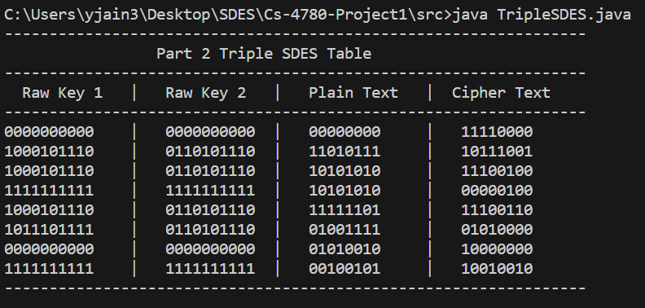

The above screenshot has the answers to the problems given in Part 2 where in we need to find the Cipher text or the Plain text of the problem using TripleSDES algorithm.

* For **Part 3**  of the project we have 3 subparts:
  + For Part 1 where we find the SDES encoding of the given CASCII plaintext, using the given key, please run the file named as SDES_Encoding.java
    - To run the file, run the command:

java SDES_Encoding.java

* + - After the above file is run successfully, we will see the below output:

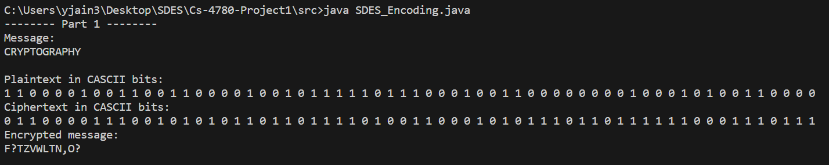

* + For Part 2 and 3 where we decrypt the given messages that are encoded using SDES and TripleSDES, please run the file named Message_Encoding.java
    - To run the file, run the command:

java Message_Encoding.java

* + - After the above file is run successfully, we will see the output:

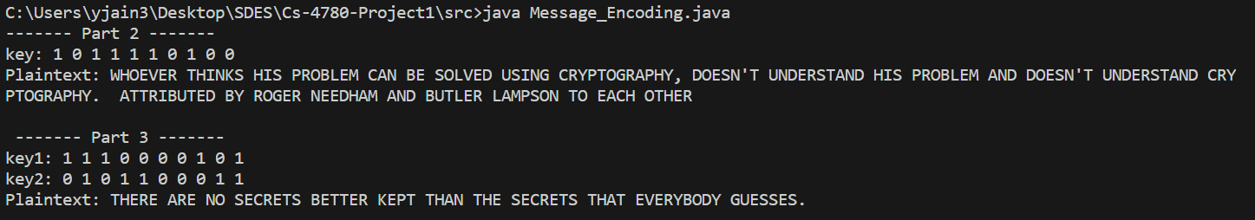

Submitted By:

Yash Kumar Jain

Yash Shah

Daniel Jimenez